This is The Trading Strategy The Top 5% Use.

Rules bullish trend:

- Wait on 20 MA Black line to be above the 50 MA Blue line
- Wait on the market to pull back and touch at least the 20 moving average
- Candles must not close below the 50 MA
- Wait on the market to break out of the last swing high.
- The close of that candle is going to be our entry
- Stop loss was one ATR below my entry candle
- Breakout is the break and close above the highs of the previous swing high.
- Entry is a close above highs of previous swing high

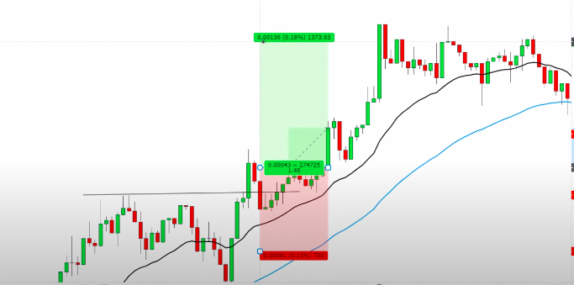

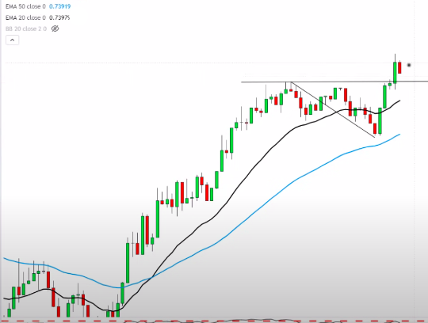

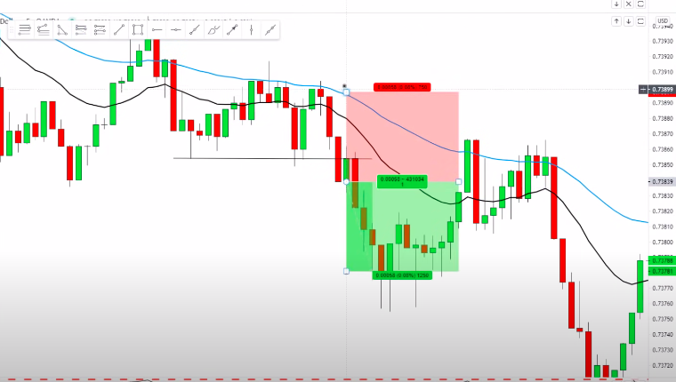
Bearish version

- Wait on 20 MA BBL to be BELOW the 50 MA BL
- Wait on the market to pull back and touch at least the 20 moving average
- Candles must not close ABOVE the 50 MA
- Wait on the market to break out of the last swing LOW.
- The close of that candle is going to be our entry
- Stop loss was one ATR below my entry candle

